# **PyCitySchool Analysis Report**

**Create a report that includes the following data. Your report must include a written description of at least two observable trends based on the data.**

PyCitySchool Analysis give access to every student's math and reading scores, as well as various information on the schools they attend. The task is to aggregate the data to showcase obvious trends in school performance.

**District Summary**

Perform the necessary calculations and then create a high-level snapshot of the district's key metrics in a DataFrame.

Include the following:

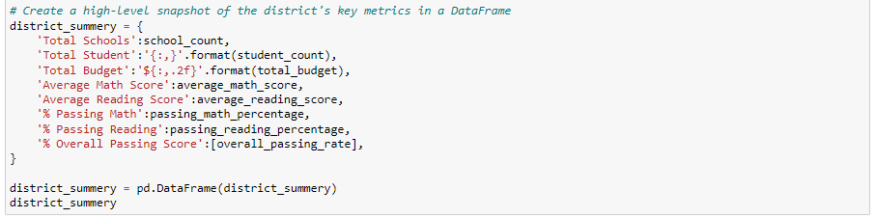

**Highest-Performing Schools (by % Overall Passing)**



#### Lowest-Performing Schools (by % Overall Passing)

#### 

**Math Scores by Grade**

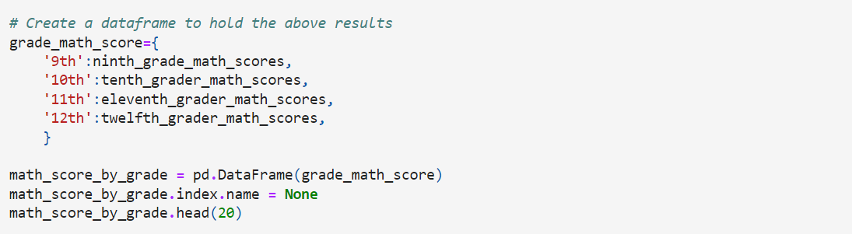

#### Reading Scores by Grade

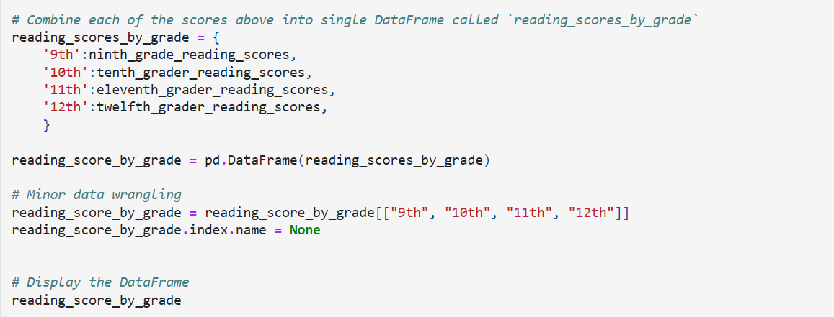

**Scores by School Spending**

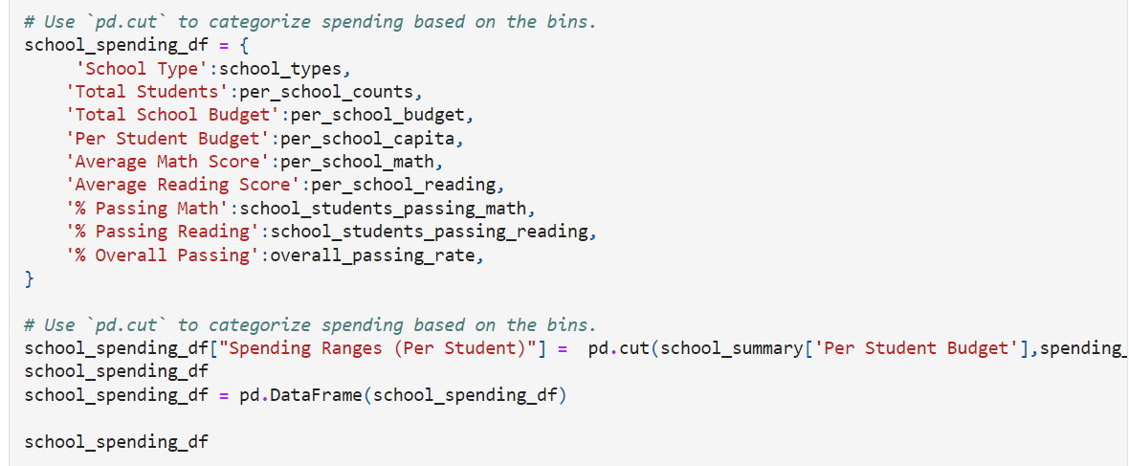

# observable trends based on the data

1) Charter Schools dominated the top 5 schools in overall passing rate and District dominated the bottom 5.

2) Larger school size and larger school spending doesn't represent efficiency.

The lower spending ranges (per student: $585-$630, <$585) and size (1000-2000, <1000) yield best results.

3) ) Charter Schools are also showing better passing and math & reading scores.